**Epiphany**

What is Epiphany?-Epiphany is a Christian holiday primarily commemorating the Magi’s visit to the baby Jesus and the baptism of Jesus by John the Baptist. Eastern traditions, which usually call the holiday Theophany, focus on Jesus’ baptism, seen as the manifestation of Christ as both fully human and fully divine. Western traditions focus on the Magi’s visit, seen as the first manifestation of Christ as saviour of Gentiles as well as Jews. Epiphany is among the church’s oldest and most important feasts.-When is Epiphany?-Epiphany is observed on January 6 by Roman Catholics, Lutherans,Anglicans, and Christians of other Western traditions. Eastern traditions that follow the Julian calendar rather than the Gregorian calendar celebrate Epiphany on January 19, since their Christmas Eve falls on January 6.-What is the origin of Epiphany?-Epiphany originated in the Eastern church and at first included a celebration of Jesus’ birth. By 354 E Jesus’ birth was being celebrated in Rome on December 25, and later in the 4th century the church in Rome began celebrating Epiphany separately on January 6.-What does the name Epiphany mean?-The name Epiphany comes from the Greek epiphaneia, meaning “appearance” or “manifestation,” and refers to the manifestation of Jesus Christ to the world. The holiday is also called the Feast of Epiphany, Theophany, or Three Kings’ Day.

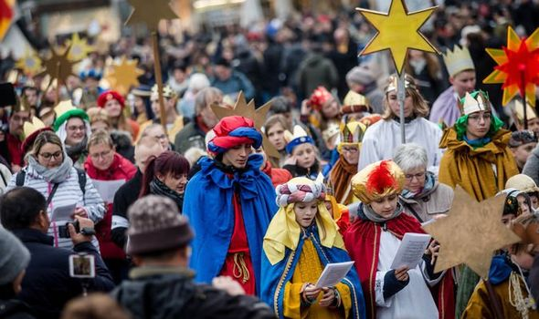

What is Epiphany?-Epiphany is a Christian holiday primarily commemorating the Magi’s visit to the baby Jesus and the baptism of Jesus by John the Baptist. Eastern traditions, which usually call the holiday Theophany, focus on Jesus’ baptism, seen as the manifestation of Christ as both fully human and fully divine. Western traditions focus on the Magi’s visit, seen as the first 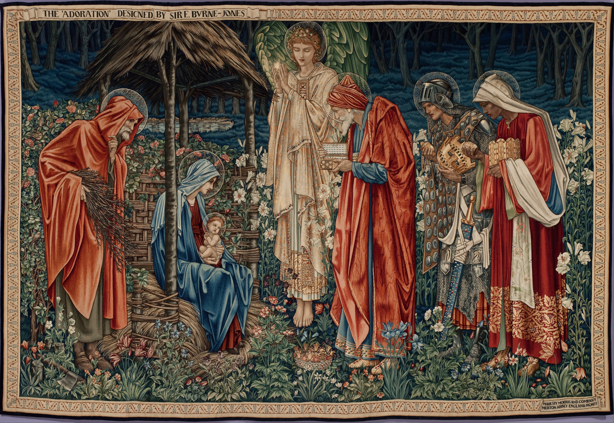manifestation of Christ as saviour of Gentiles as well as Jews. Epiphany is among the church’s oldest and most important feasts.-When is Epiphany?-Epiphany is observed on January 6 by Roman Catholics, Lutherans,Anglicans, and Christians of other Western traditions. Eastern traditions that follow the Julian calendar rather than the Gregorian calendar celebrate Epiphany on January 19, since their Christmas Eve falls on January 6.-What is the origin of Epiphany?-Epiphany originated in the Eastern church and at first included a celebration of Jesus’ birth. By 354 E Jesus’ birth was being celebrated in Rome on December 25, and later in the 4th century the church in Rome began celebrating Epiphany separately on January 6.-What does the name Epiphany mean?-The name Epiphany comes from the Greek epiphaneia, meaning “appearance” or “manifestation,” and refers to the manifestation of Jesus Christ to the world. The holiday is also called the Feast of Epiphany, Theophany, or Three Kings’ Day.